

NUMER SPECJALNY – 3/2022/2023

Poświęcony Jesieni i Jedzeniu,

dla (nie tylko) miłośników języków obcych.

Ktoś powiedział -„**Jesień** to druga wiosna, kiedy każdy liść jest kwiatem”.

Czy mamy na nią szansę w Warszawie?



What to do in Warsaw during Autumn?

You can go for a walk in [Royal Łazienki Park](https://warsawtour.pl/en/project/lazienki-krolewskie-museum-2/)– one of the most beautiful park and palace complexes in Europe, or in the Saxon Garden – the oldest public park in the capital, or maybe in Skaryszewski Park in the Praga district, next to the National Stadium. This is a time when Warsaw’s parks and streets glitter with the colours of falling leaves: gold, copper, red, orange and yellow. Don’t forget to take a camera with you – at this time of year Warsaw is extremely bautiful!



Photos from : <https://www.polska.travel/pl/aktualnosci/jesienne-inspiracje-w-lazienkach-krolewskich>

<https://stock.adobe.com/pl/search?k=%22park+skaryszewski%22>

Po spacerze zapraszamy do kuchni.

( Konieczna znajomość języka angielskiego lub słownik oraz chęci do gotowania).

**Pumpkin soup**

Ingredients

2 tbsp olive oil

2 onions, chopped

1kg pumpkin, peeled, deseeded and chopped

700ml vegetable stock or chicken stock

150ml double cream

For the croutons

2 tbsp olive oil

4 slices of bread

handful pumpkin seeds

Method

STEP 1

Heat 2 tbsp olive oil in a large saucepan, then gently cook 2 chopped onions for 5 mins, until soft but not coloured.

STEP 2

Add 1kg pumpkin to the pan, then carry on cooking for 8-10 mins, stirring occasionally until it starts to soften.

STEP 3

Pour 700ml vegetable or chicken stock into the pan and season with salt and pepper, boil for 10 mins.

STEP 4

Pour 150ml double cream into the pan, bring back to the boil, then purée with a hand blender. The soup can now be frozen for up to 2 months.

STEP 5

To make the croutons: cut 4 slices wholemeal seeded bread into small squares.

STEP 6

Heat 2 tbsp olive oil in a frying pan, then fry the bread until it starts to become crisp.

STEP 7

Add a handful of pumpkin seeds to the pan, then cook for a few mins more until they are toasted.

SŁOWNICZEK:

tbsp - tablespoon - łyżeczka

double cream - śmietana kremówka

handful - garść

stock - bulion

croutons – grzanki

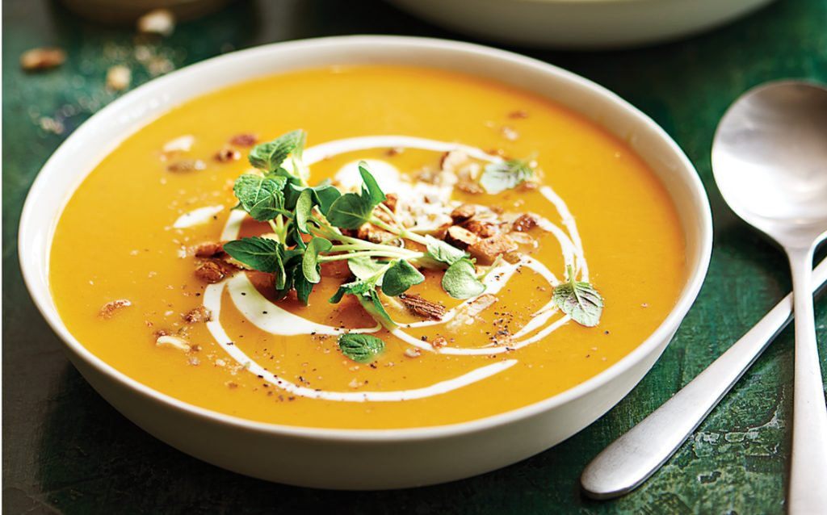

Photo from : <https://www.google.com/url?sa=i&url=https%3A%2F%2Fwww.healthyfood.com%2Fhealthy-recipes%2Fcreamy-pumpkin-soup%2F&psig=AOvVaw32_nbBD0JQsgCOkxPgs5ab&ust=1666696990015000&source=images&cd=vfe&ved=0CAoQjRxqFwoTCIil_qXg-PoCFQAAAAAdAAAAABAD>

**Smacznego**

życzą

**oraz Łazienki i Park Skaryszewski na spacer**

polecają:

Klasa 8G ( teksty w j. angielskim)

Angelika Duda,

Nauczyciele Bibliotekarze.

27 10 2022 r