Spotkania z ciekawymi ludźmi

-ze strażakiem, grafikiem komputerowym

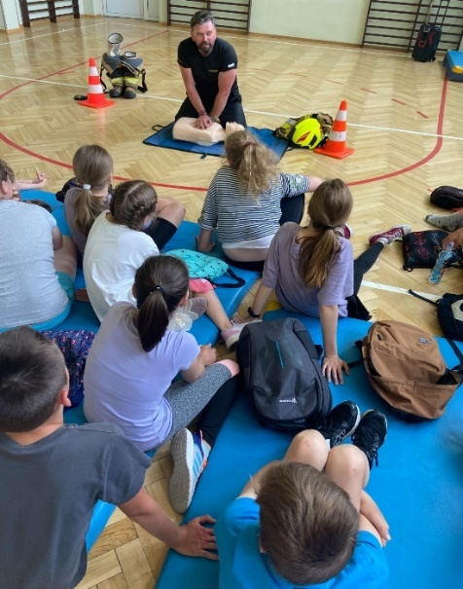
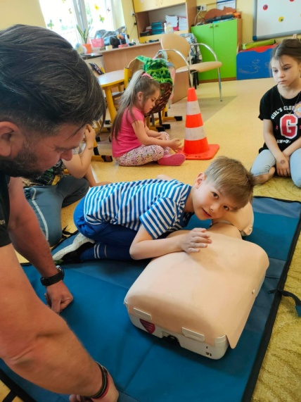

https://spborowa.edupage.org/news/?eqa=d2lkPW5ld3NfTmV3c18xX3AmbmV3c2FyY2hpdmVmPTIwMjMtMDYmb2Zmc2V0X25ld3NfTmV3c18xX3A9MA%3D%3D

Wycieczki szkolne: Warszawa Kraków Lisowa Biały Bór
Baranów Sandomierski,
Wycieczki tematyczne: do drukarni

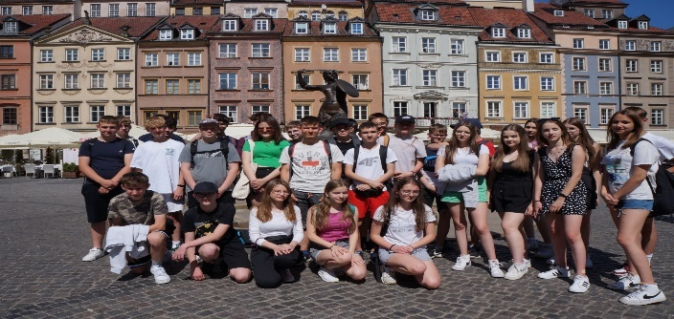
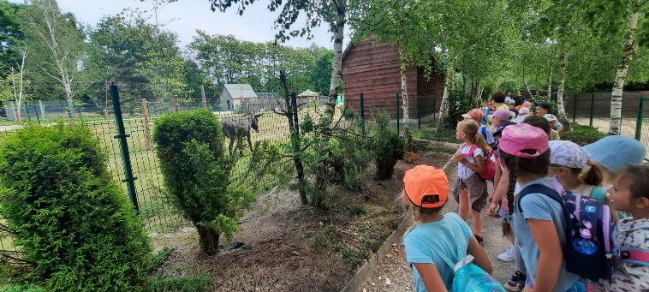

https://spborowa.edupage.org/news/?eqa=d2lkPW5ld3NfTmV3c18xX3AmbmV3c2FyY2hpdmVmPTIwMjMtMDYmb2Zmc2V0X25ld3NfTmV3c18xX3A9MA%3D%3D

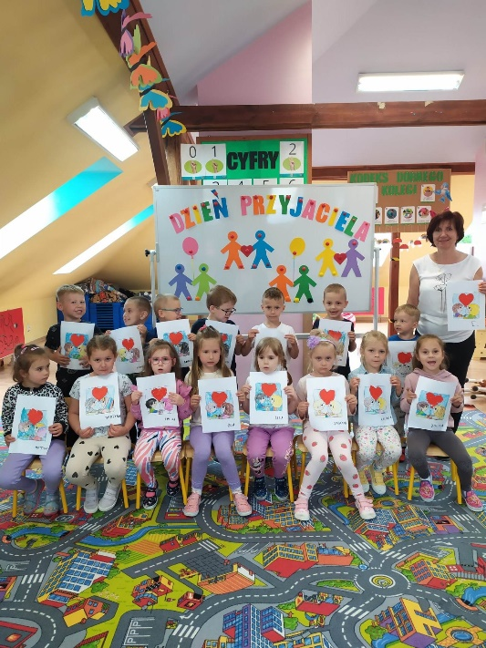
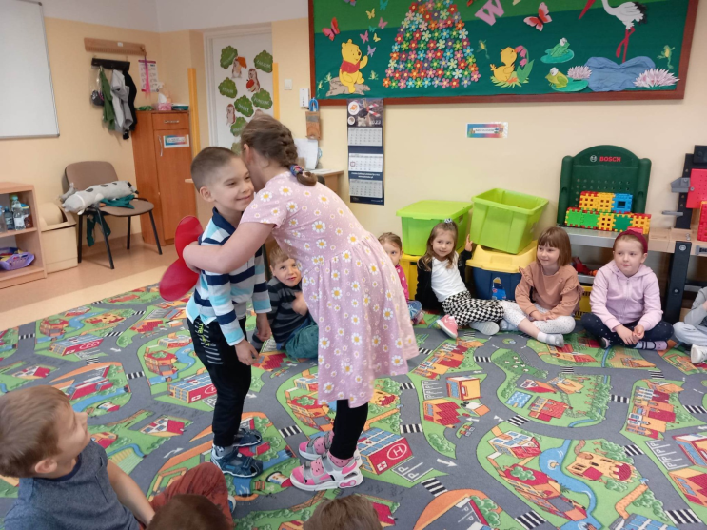

https://spborowa.edupage.org/news/?eqa=d2lkPW5ld3NfTmV3c18xX3AmbmV3c2FyY2hpdmVmPTIwMjMtMDYmb2Zmc2V0X25ld3NfTmV3c18xX3A9MA%3D%3D

Dzień przyjaciela w przedszkolu

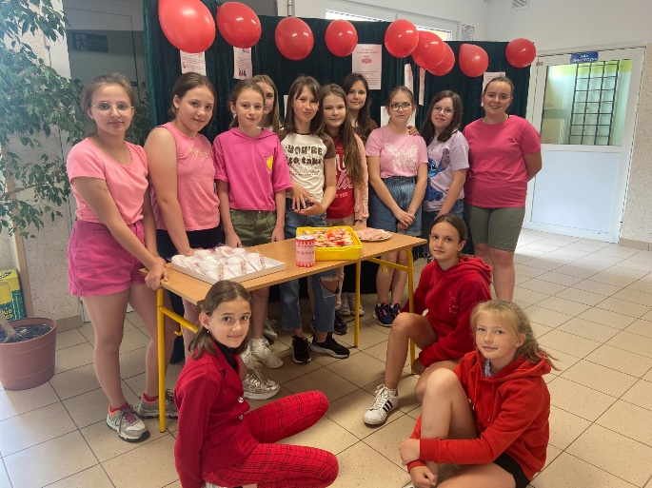

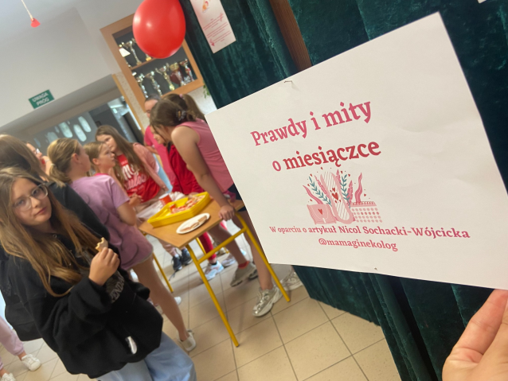

https://spborowa.edupage.org/news/?eqa=d2lkPW5ld3NfTmV3c18xX3AmbmV3c2FyY2hpdmVmPTIwMjMtMDYmb2Zmc2V0X25ld3NfTmV3c18xX3A9MA%3D%3D

Ogólnopolski projekt „Łączy nas miesiączka”

Przegląd teatrów profilaktycznych

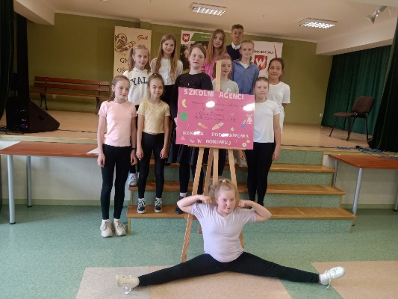
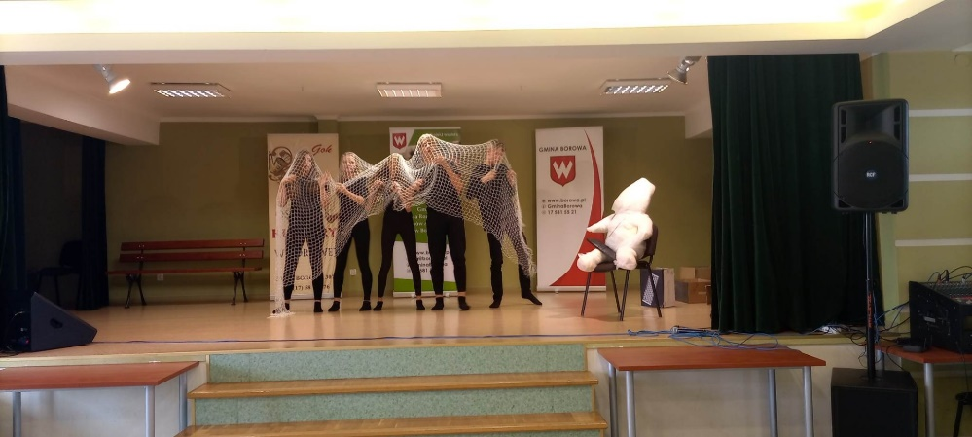

https://spborowa.edupage.org/news/?eqa=d2lkPW5ld3NfTmV3c18xX3AmbmV3c2FyY2hpdmVmPTIwMjMtMDYmb2Zmc2V0X25ld3NfTmV3c18xX3A9MA%3D%3D

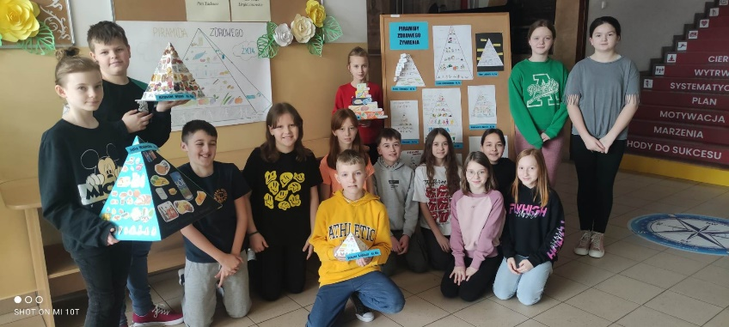

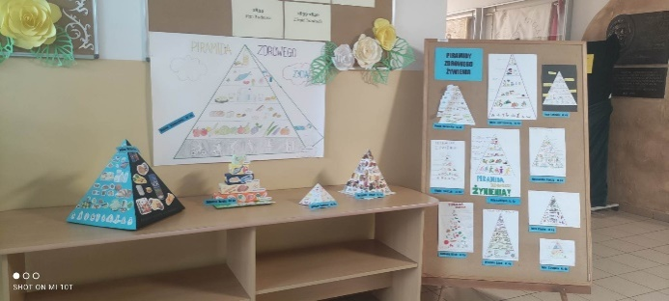

Piramidy zdrowego żywienia czwartoklasistów!

https://spborowa.edupage.org/news/?eqa=d2lkPW5ld3NfTmV3c18xX3AmbmV3c2FyY2hpdmVmPTIwMjMtMDYmb2Zmc2V0X25ld3NfTmV3c18xX3A9MA%3D%3D

Rolki i rowery

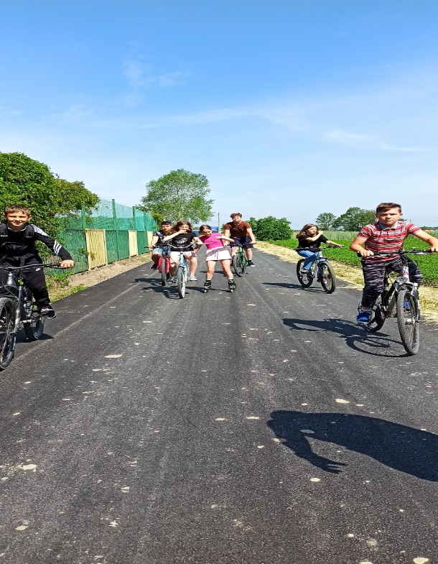

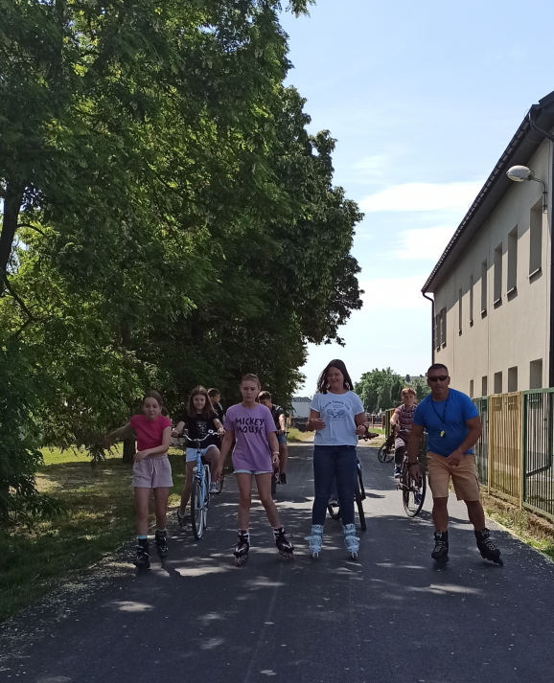
https://spborowa.edupage.org/news/?eqa=d2lkPW5ld3NfTmV3c18xX3AmbmV3c2FyY2hpdmVmPTIwMjMtMDYmb2Zmc2V0X25ld3NfTmV3c18xX3A9MA%3D%3D

Ścieżka sensoryczna obok SP Borowa..

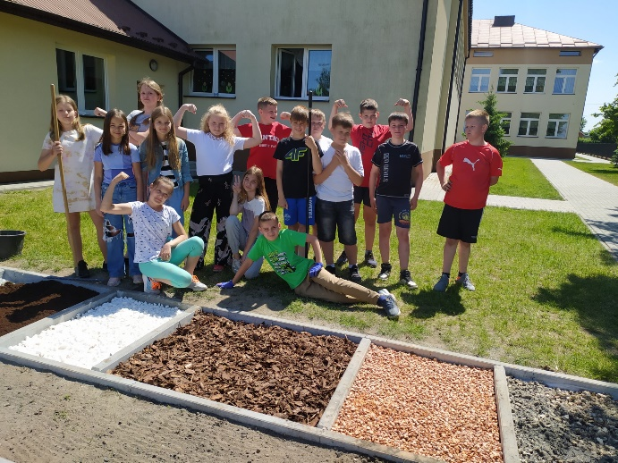

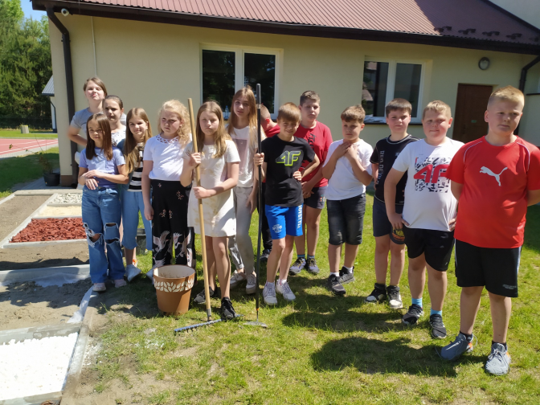
https://spborowa.edupage.org/news/?eqa=d2lkPW5ld3NfTmV3c18xX3AmbmV3c2FyY2hpdmVmPTIwMjMtMDYmb2Zmc2V0X25ld3NfTmV3c18xX3A9MA%3D%3D

Innowacja pedagogiczna „Na tropie rodzinnych talentów”

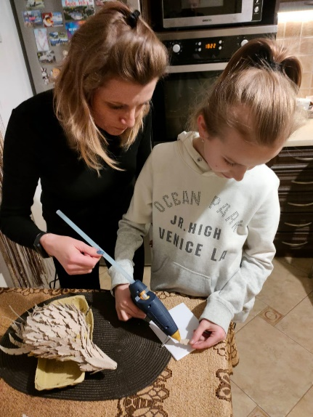
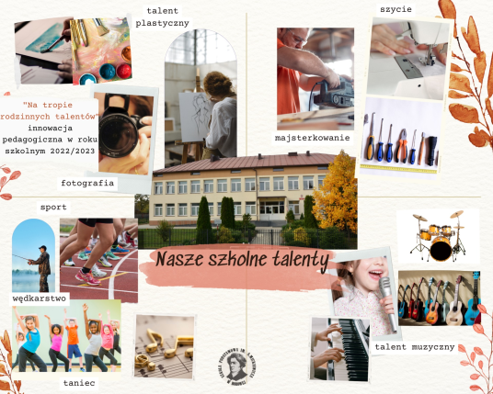

https://spborowa.edupage.org/news/?eqa=d2lkPW5ld3NfTmV3c18xX3AmbmV3c2FyY2hpdmVmPTIwMjMtMDYmb2Zmc2V0X25ld3NfTmV3c18xX3A9MA%3D%3D

Wycieczka w pole i na łąkę

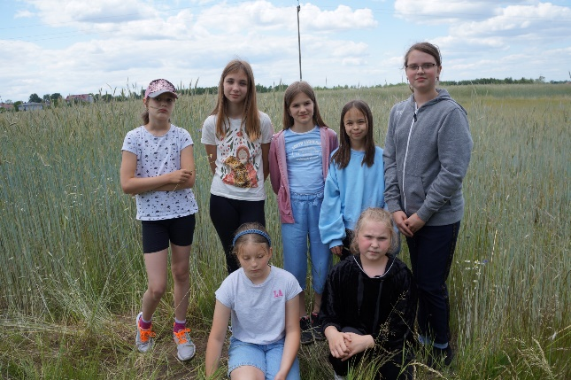
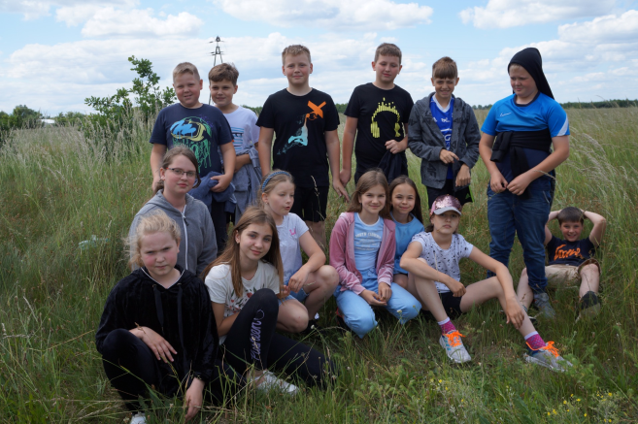
https://spborowa.edupage.org/news/?eqa=d2lkPW5ld3NfTmV3c18xX3AmbmV3c2FyY2hpdmVmPTIwMjMtMDYmb2Zmc2V0X25ld3NfTmV3c18xX3A9MA%3D%3D

Innowacja „GRAMY ZMYSŁAMI"

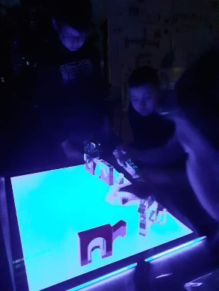
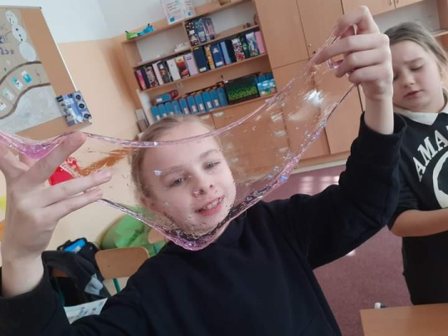

https://spborowa.edupage.org/news/?eqa=d2lkPW5ld3NfTmV3c18xX3AmbmV3c2FyY2hpdmVmPTIwMjMtMDYmb2Zmc2V0X25ld3NfTmV3c18xX3A9MA%3D%3D

Nauka pływania w klasie

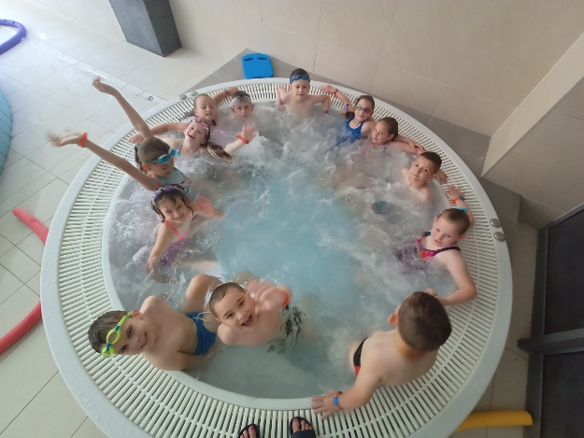

https://spborowa.edupage.org/news/?eqa=d2lkPW5ld3NfTmV3c18xX3AmbmV3c2FyY2hpdmVmPTIwMjMtMDYmb2Zmc2V0X25ld3NfTmV3c18xX3A9MA%3D%3D

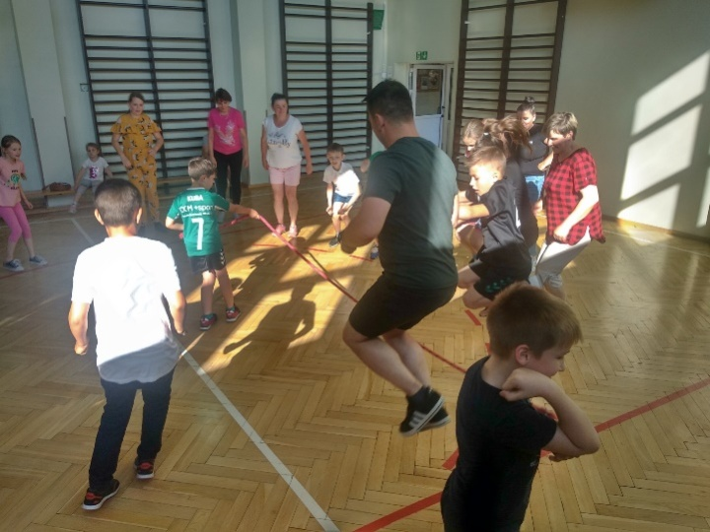
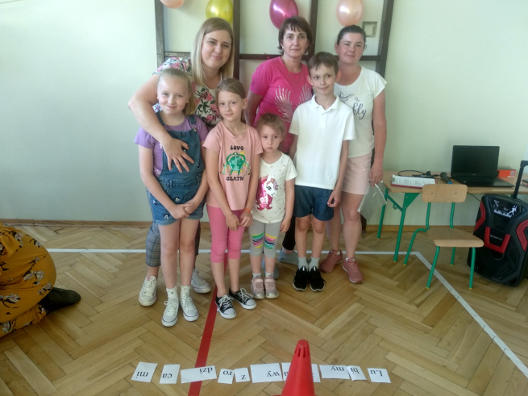

Dzień Rodziny

https://spborowa.edupage.org/news/?eqa=d2lkPW5ld3NfTmV3c18xX3AmbmV3c2FyY2hpdmVmPTIwMjMtMDYmb2Zmc2V0X25ld3NfTmV3c18xX3A9MA%3D%3D

„Otwórzmy przed nimi życie”

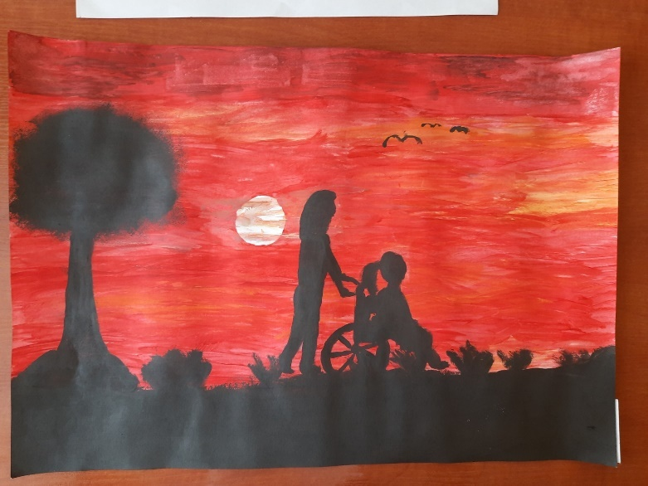
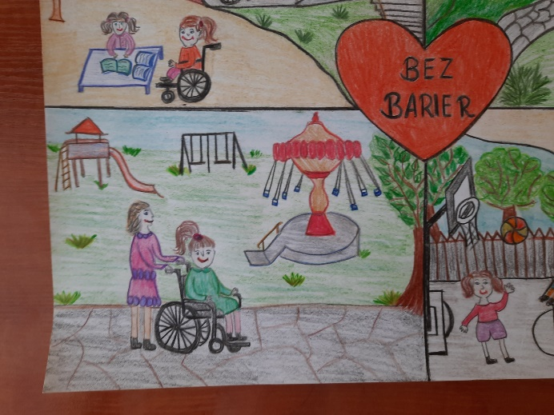

https://spborowa.edupage.org/news/?eqa=d2lkPW5ld3NfTmV3c18xX3AmbmV3c2FyY2hpdmVmPTIwMjMtMDYmb2Zmc2V0X25ld3NfTmV3c18xX3A9MA%3D%3D

Dzień Mamy i Taty

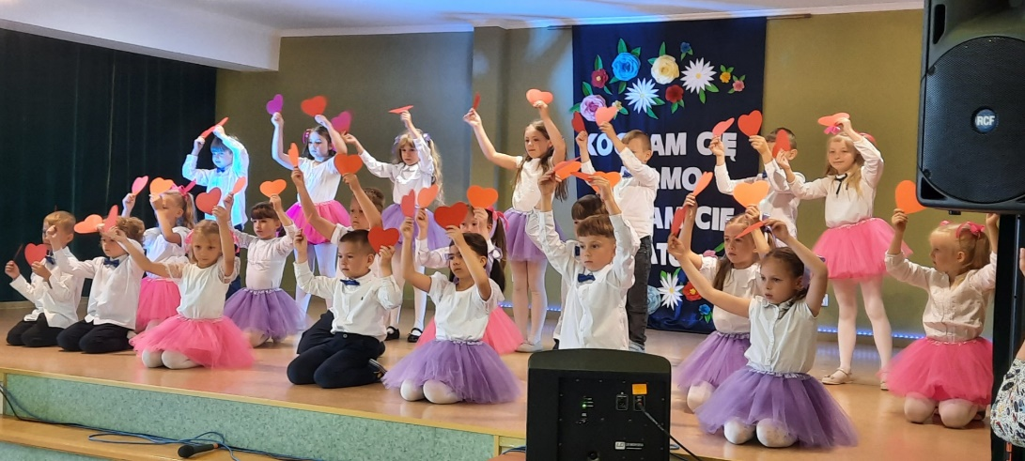
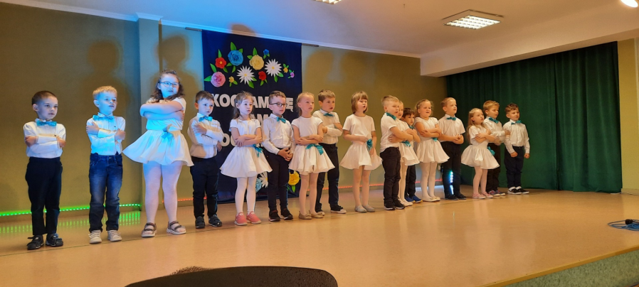

https://spborowa.edupage.org/news/?eqa=d2lkPW5ld3NfTmV3c18xX3AmbmV3c2FyY2hpdmVmPTIwMjMtMDYmb2Zmc2V0X25ld3NfTmV3c18xX3A9MjA%3D#photos:album:2086

Dbamy o przyrodę:

konkurs Ptasi album, chemiczny Alchemik, Wiosenna łąka

Lekcje przyrody w terenie, Hodowla kryształów soli

Program edukacyjny: Skąd się biorą produkty ekologiczne

Pro

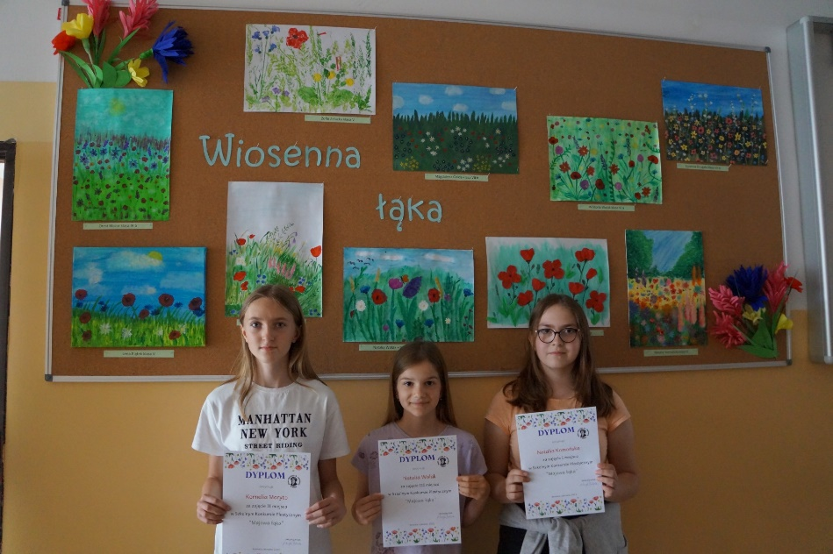
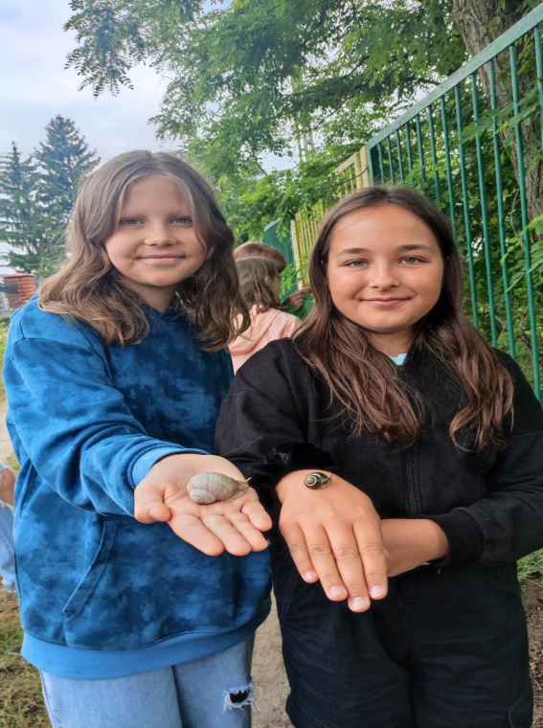
https://spborowa.edupage.org/news/?eqa=d2lkPW5ld3NfTmV3c18xX3AmbmV3c2FyY2hpdmVmPTIwMjMtMDYmb2Zmc2V0X25ld3NfTmV3c18xX3A9MjA%3D#photos:album:2088

Współpraca z rodzicami; Piknik rodzinny „Powitanie Lata” Ogniska klasowe

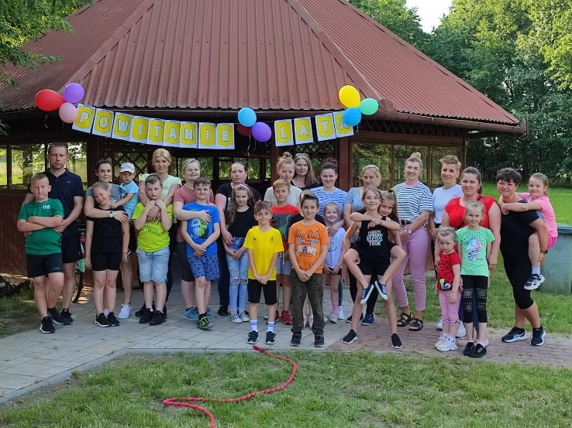

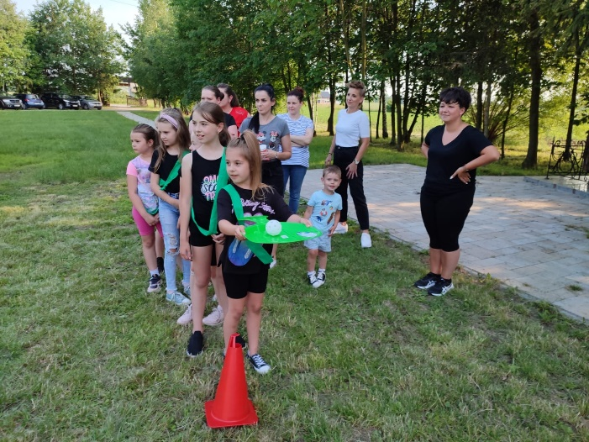

https://spborowa.edupage.org/news/?eqa=d2lkPW5ld3NfTmV3c18xX3AmbmV3c2FyY2hpdmVmPTIwMjMtMDYmb2Zmc2V0X25ld3NfTmV3c18xX3A9MA%3D%3D#photos:album:2102

Projekt edukacyjny „Wróbelka Elemelka poznajemy, z nim przygody dzielić chcemy”

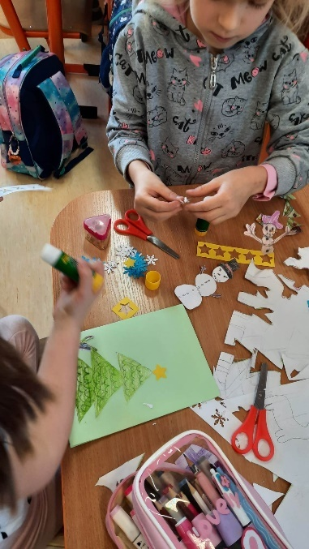
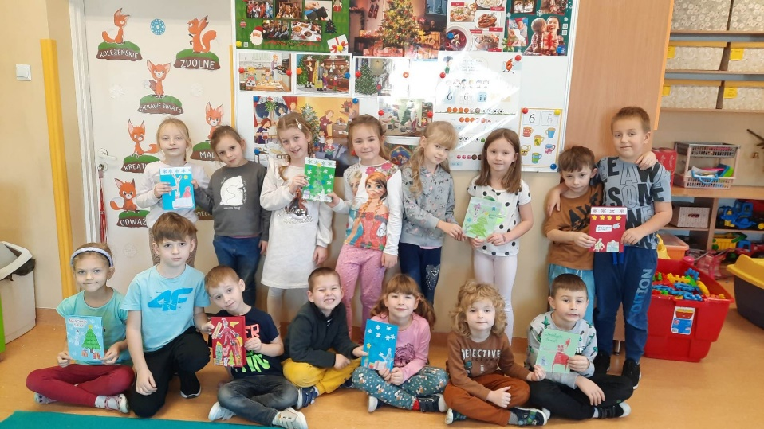

https://spborowa.edupage.org/news/?eqa=d2lkPW5ld3NfTmV3c18xX3AmbmV3c2FyY2hpdmVmPTIwMjMtMDYmb2Zmc2V0X25ld3NfTmV3c18xX3A9MA%3D%3D#

Tydzień Profilaktyki: przegląd teatrów profilaktycznych, nagrania krótkometrażowe uczniów
i pracowników: „Coś dla ciała i ducha, jak dbam o swoje zdrowie?-duży i mały ci powie”,

Wernisaż prac ”Wyrażam siebie poprzez sztukę- innowacja pedagogiczne, Sensorycznie wszystko gra- gry i zabawy w ogrodzie sensorycznym, Marsz profilaktyczny

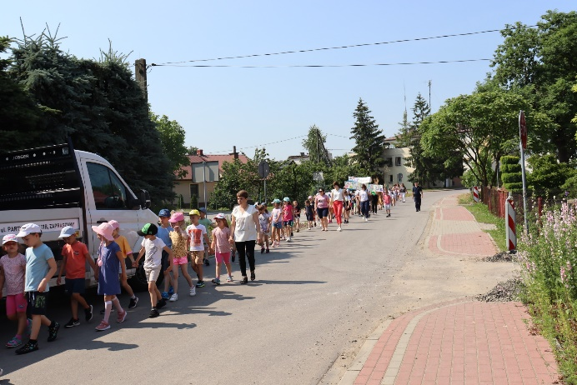
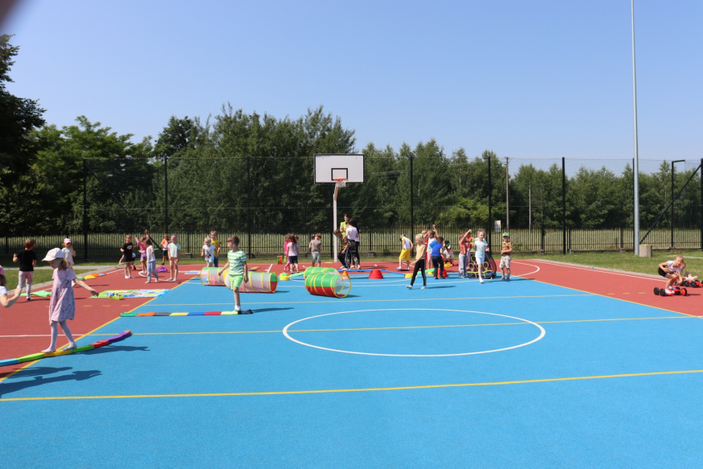
https://spborowa.edupage.org/news/?eqa=d2lkPW5ld3NfTmV3c18xX3AmbmV3c2FyY2hpdmVmPTIwMjMtMDYmb2Zmc2V0X25ld3NfTmV3c18xX3A9MA%3D%3D#

Innowacja pedagogiczna AkceptacJA

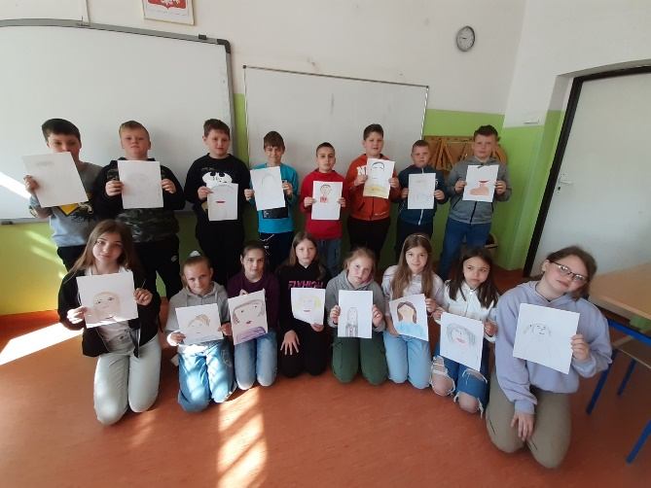
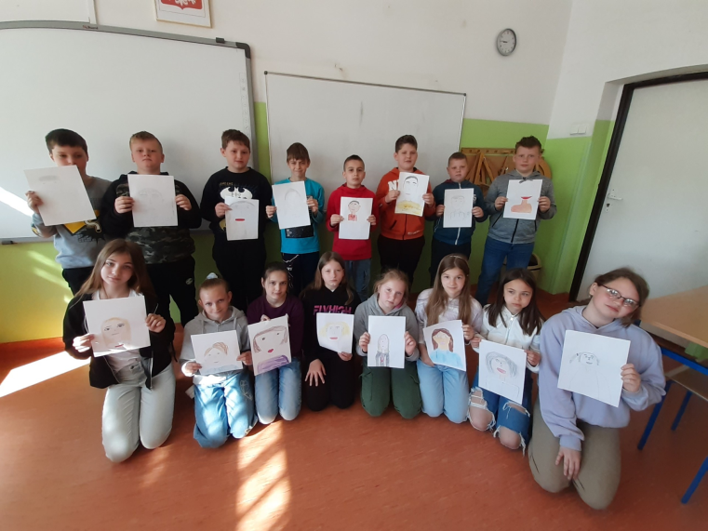
https://spborowa.edupage.org/news/?eqa=d2lkPW5ld3NfTmV3c18xX3AmbmV3c2FyY2hpdmVmPTIwMjMtMDYmb2Zmc2V0X25ld3NfTmV3c18xX3A9MA%3D%3D#

Promowanie czytelnictwa

„Szkolne drzewo czytelnicze” – edycja wiosenna

Konkursy biblioteczne

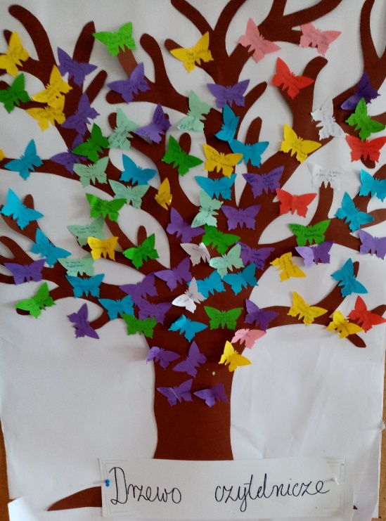
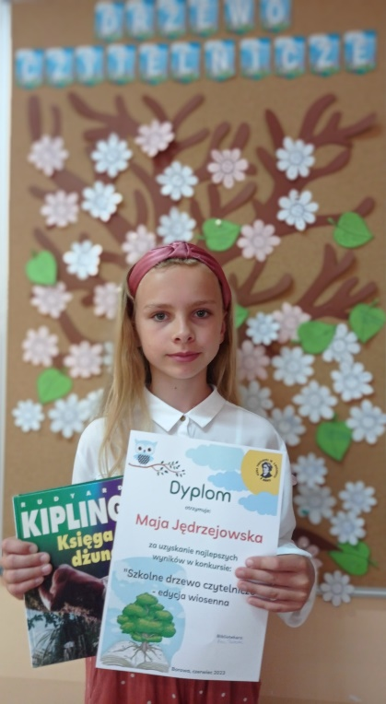

https://spborowa.edupage.org/news/?eqa=d2lkPW5ld3NfTmV3c18xX3AmbmV3c2FyY2hpdmVmPTIwMjMtMDYmb2Zmc2V0X25ld3NfTmV3c18xX3A9MA%3D%3D#

